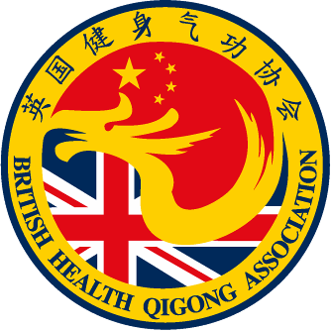 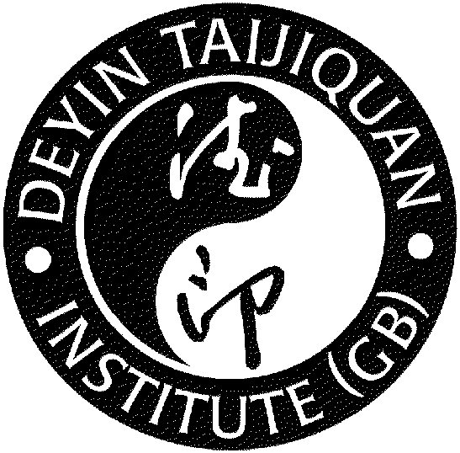

**TAI CHI & QIGONG FOR HEALTH**

Tai Chi is practised the world over for its health-giving properties

* Brings mind and body together
* Promotes tranquillity thus reducing stress
* Improves posture and balance
* Low impact - suitable for all abilities and ages

**Improves flexibility**

Health Qigong is a set of exercises based on Traditional Chinese Medicine practices dating back over 3000yrs.

Slow graceful movements to bring together mind, breathing and body to cultivate and promote health.

**Classes**

**Offley Hay Village Hall, Mondays 10:00 - 11:00**Of

**Hixon Memorial Hall, Mondays 20:00 - 21:00**

**Ashley Memorial Hall, Loggerheads, Tuesdays 14:00 - 15:00**

**Eccleshall Parish Rooms, Tuesdays 18:45- 19:45 Beginners.**

**Eccleshall Parish Rooms, Tuesdays 20:00 - 21:00 Improvers.**

**Woodseaves Village Hall Thursdays 19:00 - 20:00**

**Classes £7 First class free.**

**For further information, please contact David on:**

07812 769689

or

[eccleshall.taichi@gmail.com](mailto:eccleshall.taichi@gmail.com)